Algorithm description and software design specification

catalog

Ⅰ、Topic requirements 3

1.1 Title Introduction 3

1.2 Problem analysis 3

Ⅱ、Specific problem pain points and software ideas 4

2.1 Brief introduction of meteorological disasters and their causes 4

2.1.1 What is a meteorological disaster 4

2.1.2 Types and hazards of meteorological disasters 5

2.1.3 Causes of some meteorological disasters 10

2.2 Propaganda vectors for meteorological disaster prevention and main issues 12

2.2.1 Publicity 12

2.2.2 Internal pain point 14

2.2.3 Problem core 15

Ⅲ丶Problem solving ideas and algorithms 15

3.1 Choice of development platform and AR application development engine 15

3.2 Particle System 19

3.3 Proposition of software prototype 22

3.4 Optimization of this software 25

3.5 Advantages of this software 26

3.6 Algorithms of this software 27

Ⅳ、Software structure, function, module, interface, etc. 28

4.1 Software structure 28

4.2Software functions 28

4.3 Software modules and interfaces 29

4.3.1 Login and Registration Module 29

4.3.2 3D particle model rendering module 30

4.3.3 Model switching module 30

4.3.4 Disaster News Jump Module 31

4.3.5 Disaster Prevention Jump Module 31

4.3.6 Disaster introduction jump module 31

1. **Question requirements**

**1.1 Introduction**

**Multimedia visualization of meteorological data**

**Question description:**

**(1) Multimedia visualization of meteorological data. Display webpages, animations, videos, virtual 3D scenes, etc. to Chinese meteorological science data;**

**(2) Production of meteorological (process) scenes, two- and three-dimensional scenes of weather scenes;**

**(3) Produce meteorological public welfare multimedia by self-developed theme, calling for environmental protection, energy conservation and emission reduction.**

**1.2 Problem Analysis**

**By analyzing the intent of the topic, we need to display it around the theme of meteorological visualization, combining web pages, animations, videos, virtual three-dimensional scenes, and so on. There are many directions to choose from, and in order to avoid making the software large and empty, without focus, and unable to reflect the focus of the software, I decided to seize the virtual scene as the core, and use AR technology as the technical background to link virtual and display Get up to reflect the theme of this work. The definition of AR is augmented reality and mixed reality. It needs to combine virtual and display, and it must be closely integrated with reality. In the requirements of the topic, the presentation of the key points should include themes of meteorological public welfare, calls for environmental protection, energy conservation and emission reduction. Therefore, our team decided to proceed from the current state of the environment in China, grasp the nature of the meteorological changes and the environmental changes that come with it, find out the pain points, and solve them with AR technology.**

**Ⅱ. Pain points of specific problems and software ideas**

**2.1 Introduction to meteorological disasters and their causes**

**2.1.1 What is a meteorological disaster**

**Meteorological disasters refer to direct or indirect damage caused by the atmosphere to human life and property, national economic construction, and national defense construction. Natural disasters can cause losses of several million to tens of billions of yuan, and they can also cause irrelevant damage in the disaster area. Number of casualties.**

**Meteorological disasters are one of the natural disasters. It mainly includes tropical storms in Asia, typhoons in coastal areas of China, droughts in the south, high temperatures, flash floods, thunderstorms, and sandstorms in northern China. Common hurricanes, tornadoes, hail, and heavy rain (snow) in North America. China is one of the few countries in the world where natural disasters occur very frequently and there are many types of disasters, causing serious losses.**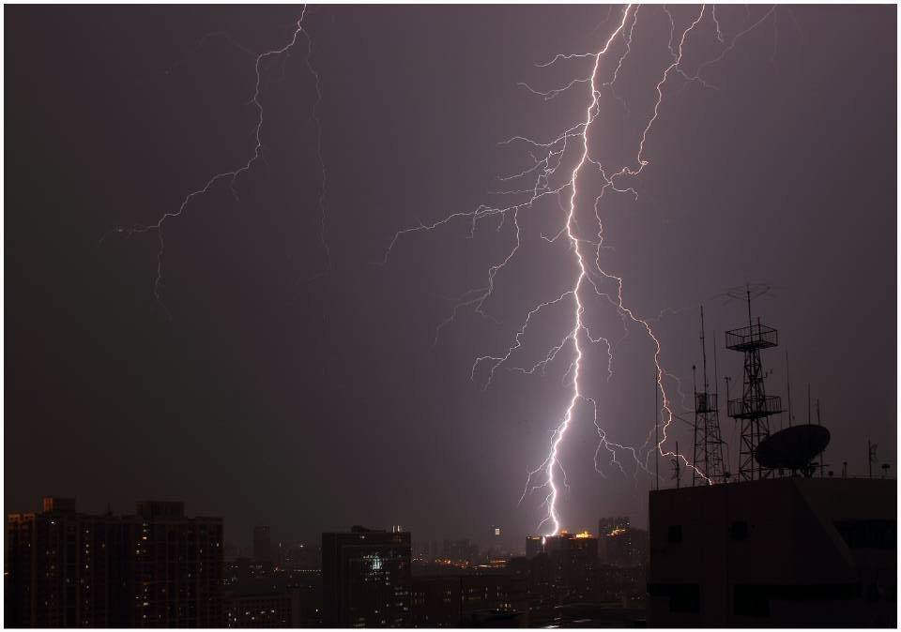

**2.1.2 Types and hazards of meteorological disasters**

**Meteorological disasters generally include weather, climate disasters and meteorological secondary and derivative disasters. Weather and climate disasters refer to typhoon (tropical storm, severe tropical storm), heavy rain (snow), thunderstorm, hail, gale, sand, tornado, heavy (dense) fog, high temperature, low temperature, continuous rain, freezing rain, frost , Disasters caused by factors such as icing (accumulation) of ice, cold wave, drought, dry and hot wind, heat wave, flood, and waterlogging. Meteorological secondary and derivative disasters refer to landslides, landslides, storm surges, forest fires, acid rain, air pollution and other disasters caused by meteorological factors.**

**There are more than 20 types of meteorological disasters, mainly including the following:**

**⑴Rainstorms: flash floods, river floods, and urban waterlogging;**

**⑵Waterlogging: waterlogging and waterlogging;**

**(3) Drought: drought in agriculture, forestry, grassland, water shortage in industry, cities, and rural areas;**

**⑷Dry hot wind: drought wind, foehn wind;**

**⑸High temperature and heat wave: extreme heat, human diseases, burns, and crops becoming ripe;**

**⑹Tropical cyclones: strong winds, heavy rains, floods;**

**⑺Chilling damage: damage to crops, livestock, and fruit trees due to strong cooling and low temperatures;**

**⑻ Frost damage: frost damage to crops and livestock, freezing of water pipes and oil pipes;**

**⑼ Freezing rain: the wires, branches, and roads are frozen;**

**⑽Icing: the river, lake, and sea are frozen, and the road freezes after rain and snow;**

**⑾ Snow damage: snowstorm, snow cover;**

**Hail damage: destroy crops and houses;**

**⒀Wind damage: fallen tree, house, car or boat;**

**⒁ Tornado: locally destructive disaster;**

**⒂ Lightning and lightning: Lightning strike casualties;**

**Coptis rain (fornication rain): It is not good for crop growth and development, food mildew, etc.**

**⒄Condensed fog: human diseases and traffic obstruction;**

**⒅Low-altitude wind shear: (aircraft) aviation crash;**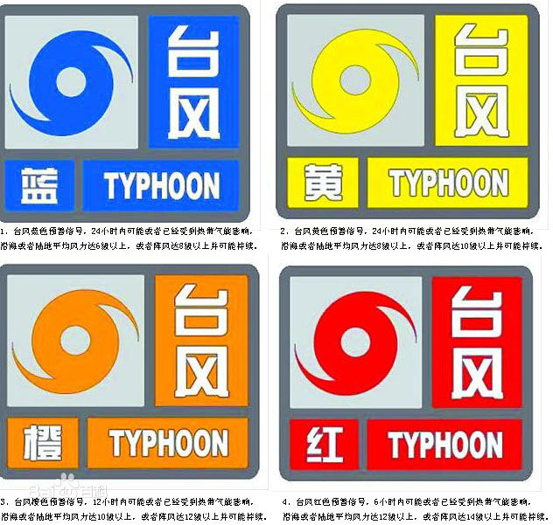

**Hazards of some major meteorological disasters:**

**drought:**

**It is a severe enough period of time that the precipitation is severely insufficient, causing the soil to lose water due to evaporation, reducing the flow of rivers, and disrupting normal crop growth and catastrophic weather phenomena of human activity. As a result, crops and fruit trees are reduced in yield, people, livestock have difficulty drinking water, and industrial water is scarce. Drought is the most severe meteorological disaster affecting China's agriculture, causing considerable losses. According to statistics, the average annual drought-affected area of Chinese crops amounts to more than 300 million acres, and the area affected by disasters reaches 120 million acres. The average annual reduction in output due to drought amounts to 10 billion to 5 billion kilograms, and the annual economic loss due to lack of water amounts to 200 billion yuan. . Drought and water shortages exist in more than 420 cities in China, with 110 cities having severe water shortages. The country ’s annual output value due to urban water shortages amounts to 200 billion to 300 billion yuan.**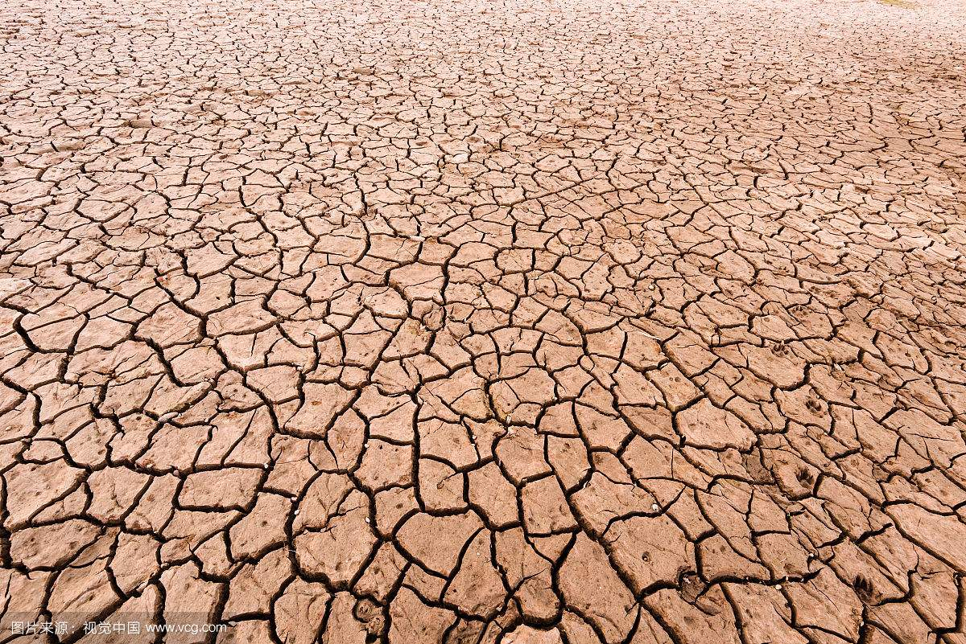

**rainstorm:**

**It is a short-time or continuous heavy precipitation process. In low-lying terrain and closed terrain, rain cannot be drained quickly, causing farmland water accumulation and excessive soil moisture saturation to bring disasters to agriculture; heavy rainfall can even cause mountain floods, rivers, The dam breach caused significant economic losses to the people and the country. According to the Chinese Meteorological Department, rain with a rainfall of 50 mm or more in a 24-hour period is called "storm". The Yangtze River Basin is a region where rainstorms and floods occur frequently, and the two lake basins and the Yangtze River Delta are particularly affected. Serious rainstorms and floods occurred in 1983, 1988, 1991, 1998 and 1999.**

**tropical wind:**

**Tropical cyclones are collectively called strong vortices with high central temperature and low air pressure formed in the tropical ocean atmosphere. It causes severe weather such as squalls, heavy rains, huge waves and storm surges, which is a very destructive weather phenomenon. The average annual loss caused by it is more than 10 billion yuan. Like the "Yunna", which landed in Zhejiang in 2004, the loss caused by it is over 10 billion yuan.**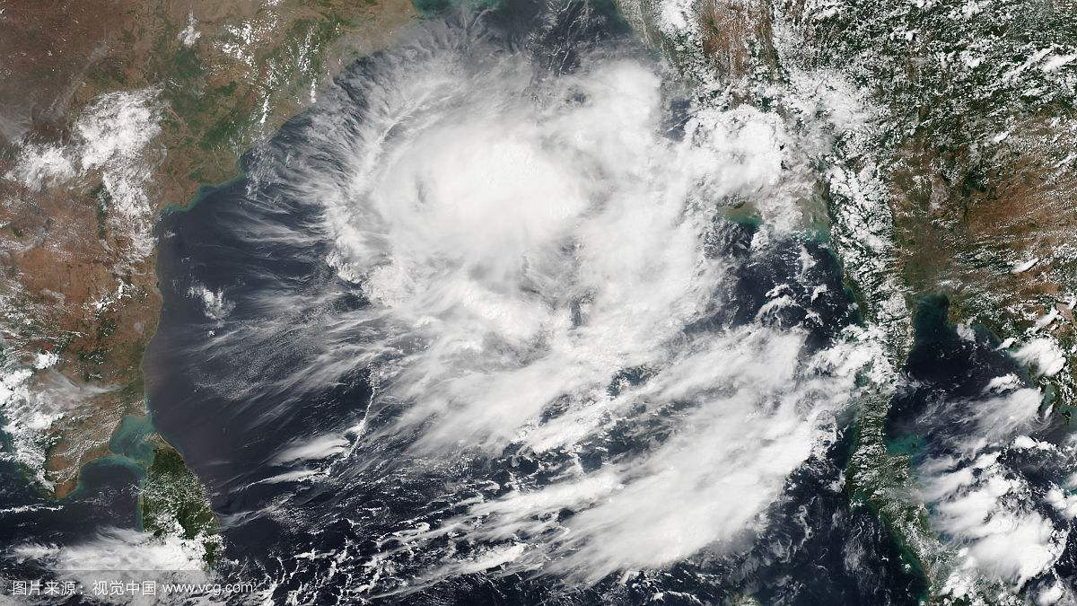

**Hail:**

**Hail disaster refers to the disaster caused by the ice cubes condensed in cumulonimbus clouds falling from the air under the control of convection weather. Hail often smashes large**

**Crops, orchards, damage to buildings, and threats to human safety are a serious natural disaster, usually occurring in summer and autumn. The area where the hailstorm disaster occurred in China is very wide. According to statistics, the area affected by the hailstorm in agriculture was more than 99 million mu (1993) and the year of light disaster was more than 56 million mu (1994).**

**Freezing:**

**Low-temperature freezing disasters are mainly agricultural meteorological disasters caused by the continuous multi-day temperature drop caused by the intrusion of cold air and cold waves. Years of severe frost damage, such as 1968, 1975, and 1982, caused more than 20% of the area destroyed by frost damage to seedlings. The severe cold wave from October 25th to 29th, 1977 caused a snow depth of 0.5 meters in Inner Mongolia and Xinjiang, the grassland was buried, and a large number of livestock died.**

**Snow disaster:**

**The long-term heavy snowfall caused a large-scale natural disaster. The hazards are: it seriously affects or even destroys lifeline projects such as transportation, communication, and transmission lines, and has a huge impact on people's production and life. In December 2005, Weihai, Shandong and Yantai suffered the largest snowstorm in 40 years. The direct economic loss caused by the snowstorm amounted to 374.3 million yuan.**

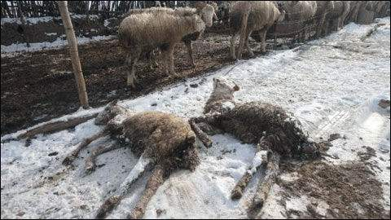

**2.1.3 Causes of some meteorological disasters**

**typhoon:**

**Cause: The typhoon originated in the tropical sea, where the temperature was high, and a large amount of seawater was evaporated into the air, forming a low-pressure center. With the change of air pressure and the movement of the earth itself, the incoming air also rotates, forming a counter-clockwise air vortex. This is the tropical cyclone. As long as the temperature does not drop, this tropical cyclone will become stronger and stronger, and eventually a typhoon will form.**

**Hazard: Gale, heavy rain, storm surge. Typhoons often bring stormy weather when they cross the border, causing huge waves on the sea surface, which seriously threaten the safety of navigation. The increase in storm water brought by the typhoon's landing may destroy crops and various construction facilities, causing huge loss of people's lives and property.**

**Distribution: It often occurs on tropical oceans with latitudes of 5-25 degrees in the north and south.**

**Heavy rain and flood:**

**Cause: Rainfall is a meteorological disaster caused by excessive rainfall.**

**Harm: Causes flood disasters and severe soil erosion, leading to major economic losses such as engineering accidents, bankruptcies and flooding of crops. Especially in some low-lying areas with closed terrain, rainwater cannot be quickly released, which causes over-saturation of farmland water and soil moisture, which will cause more disasters.**

**Distribution: middle and low latitudes, middle and lower reaches**

**drought:**

**Causes: Plant system distribution, temperature equilibrium distribution, changes in atmospheric circulation, changes in chemical element distribution caused by drought and human activities have a direct relationship with system changes related to human activities, the greenhouse effect.**

**Hazards: It leads to the decline of human immunity, harms the production of agriculture and animal husbandry, promotes further deterioration of the ecological environment, and other natural disasters caused by the warming and drying of the climate.**

**Distribution: Subtropical area**

**Cold wave:**

**Cause: In the Arctic region, due to the weak sunlight, the ground and the atmosphere get less heat, and it is snowy all year round. In winter, the position of direct sunlight crosses the equator and reaches the southern hemisphere. The coldness in the Arctic region has increased, and the range has expanded. The temperature is generally below -40 ° C-50 ° C. Large-scale cold air masses gather to a certain extent, and under the action of appropriate high-altitude atmospheric circulation, they will invade southward on a large scale and form cold wave weather.**

**Hazards: Freezing damage to crops (the greatest damage in spring and autumn), overturning ships, destroying buildings, destroying farms. Squeeze the wires and break the poles.**

**Distribution: Central Siberia**

**2.2 Propaganda vehicles for meteorological disaster prevention and main issues**

**Above we learned that meteorological disasters have a very large impact on human daily life and even life, so how to make people aware of this "natural" threat is the object we need to focus on.**

**2.2.1 Publicity methods:**

**According to our understanding, the ways in which people can access meteorological disaster-related content in daily life are: weather forecast, news reports, meteorological disaster propaganda and education, meteorological disaster prevention knowledge propaganda manuals, meteorological disaster propaganda videos and some public welfare advertisements.**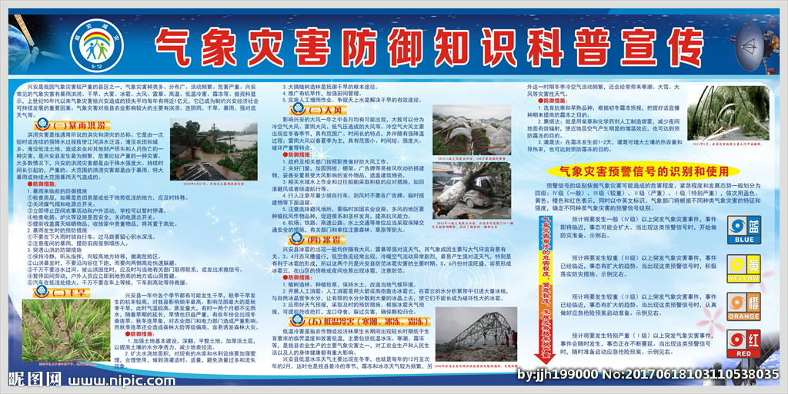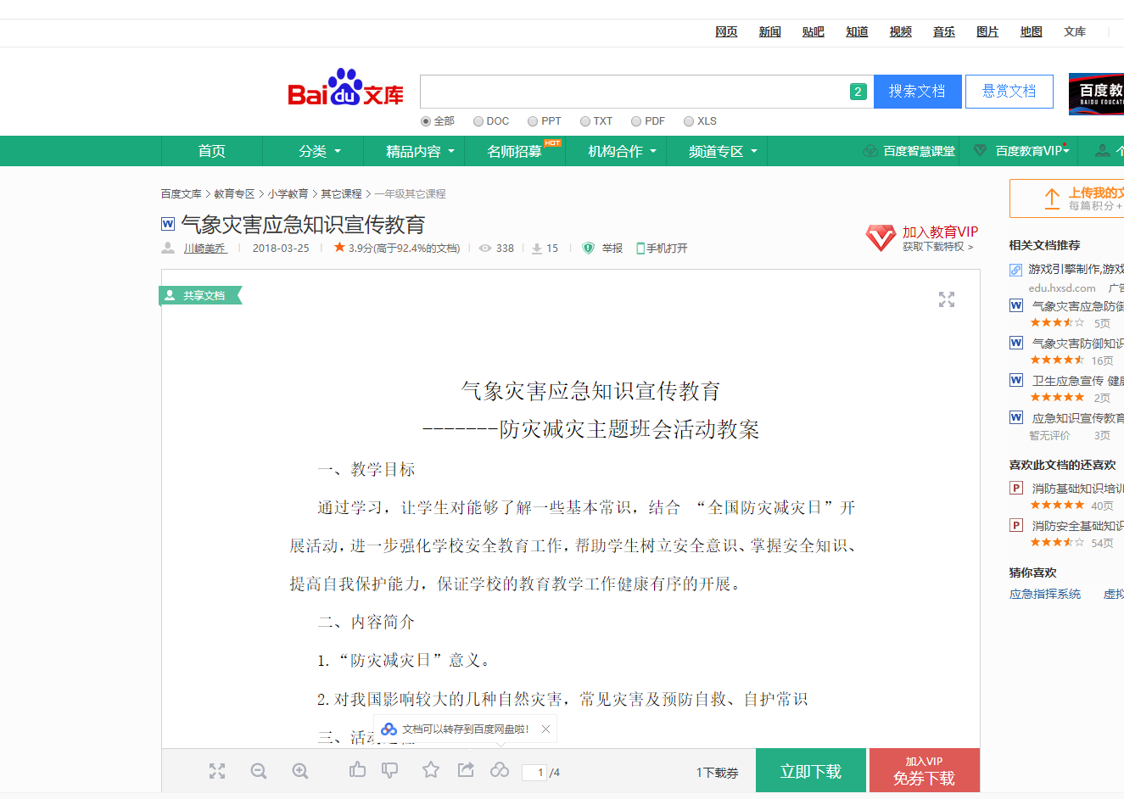

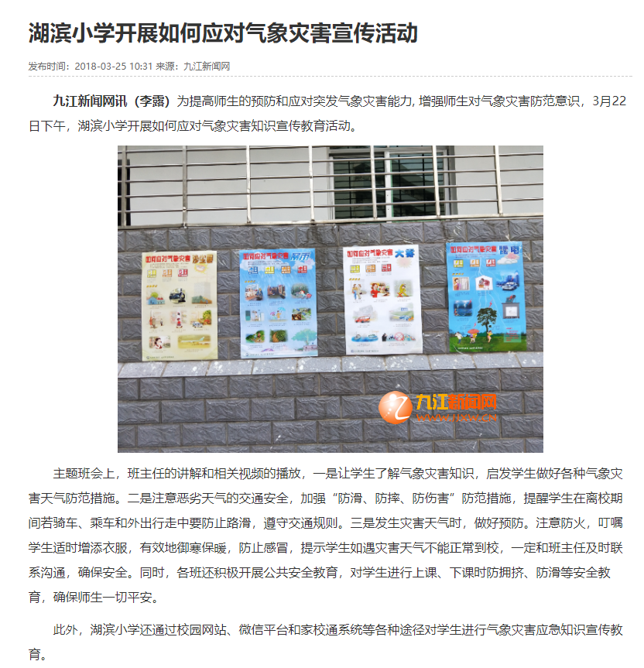

### 2.2.2 Internal Pain Points

### There seem to be many ways, and there are many channels for people to understand meteorological disasters. However, at such a fast pace of modern life, few people will stop to watch these public service advertisements and brochures, and the education of schools in this area is also Not in place. Knowledge of defense measures against meteorological disasters can be said to be very lacking, especially for modern youth, junior high school students, and contemporary college students. Therefore, it is an important issue how to let these existing knowledge, or new methods of defense against meteorological disasters, have not been discovered yet to let more people know.

**2.2.3 The core of the problem**

**To solve this problem, it is necessary to grasp the psychology of contemporary people, what they like and what they often use, and use this as the core to analyze how to improve the publicity of meteorological disasters.**

**What do people come into contact with most in everyday life? Looking at the development in recent years, from the rise of televisions to personal computers to smart phones, all the selling points have developed to be portable and thin. The most commonly used daily life is mobile phones. However, the content of the Internet is cumbersome and untargeted, and everyone can share their ideas, so whether the ideas are right or wrong and whether they are related to the topic is not important on the Internet.**

**Therefore, AR's mixed reality characteristics can be used to balance the disadvantages of the two, link online and offline, and use its augmented reality characteristics to solve. The details will be put forward in the problem solving ideas and algorithms in the next chapter.**

# Ⅲ丶Problem solving ideas and algorithms

## 3.1 Choice of development platform and AR application development engine

**First of all, in the choice of development platform, because it is developed on the mobile terminal, there are certain requirements for the 3D model and the development platform. First, the installation package should not be too large. Second, because of the hardware limitations of the mobile terminal, the 3D model is not refined. It can be too high, but it can't be like the toys or mosaic quality of children's play, and the stability for recognition.**

**As for the choice of development platform, there is the native application layer development of Android Studio and the development of game engines represented by the unity engine. I chose the unity engine. Compared to native development, unity is more powerful for the performance and interaction of 3D models. However, for built-in browsers and real-time, unity is weaker. Overall, the unity engine development revenue is higher.**

**After the platform is determined, you need to choose an AR application development engine. Currently there are industrial-grade AR application development engines, Qualcomm-developed Vuforia, and domestically-developed Easy AR, known as the most professional AR engine in China, and HiAR created by Liangfengtai Information Technology, and there is a degree of independent research and development integrated into Unity3d Too virtual AR development kits and so on.**

**Because there are many AR application development engines, the author chose Vuforia, which is the most representative in foreign countries, and EasyAR, which is the most representative in China. The first is the development documentation. Because Vuforia is an AR development engine developed by Qualcomm, the documentation is basically in English, and because domestic AR is still in its infancy, there are fewer development documentation and you need to explore it yourself. In contrast, the EasyAR engine is developed in China and is the earliest group of companies to enter the AR application development engine. Therefore, the Chinese version has many references and a large number of users.**

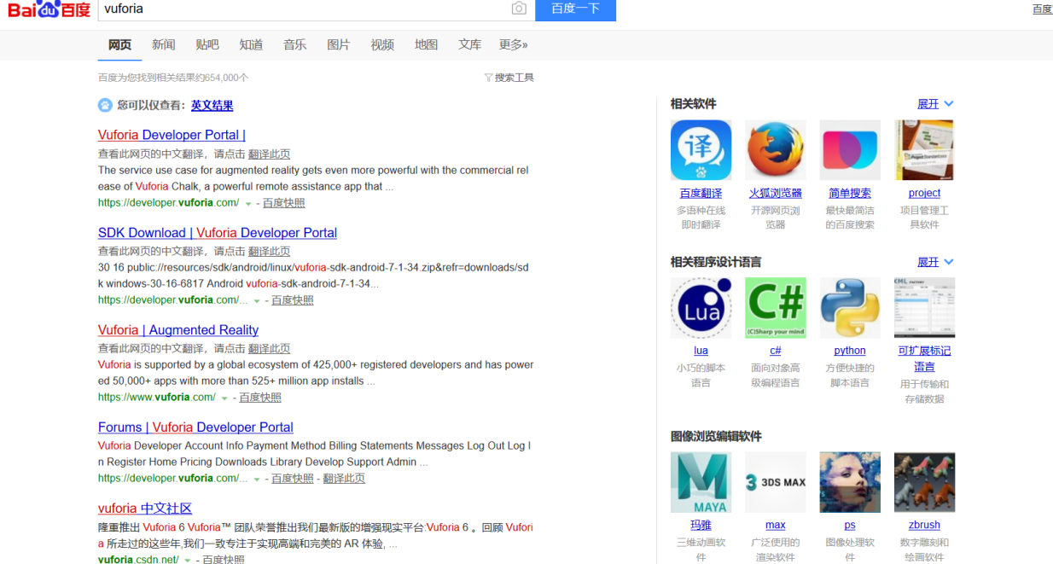

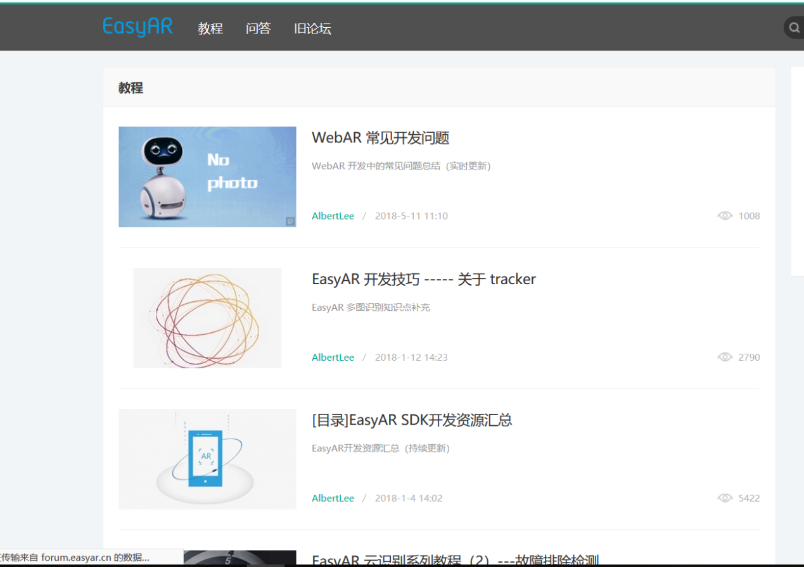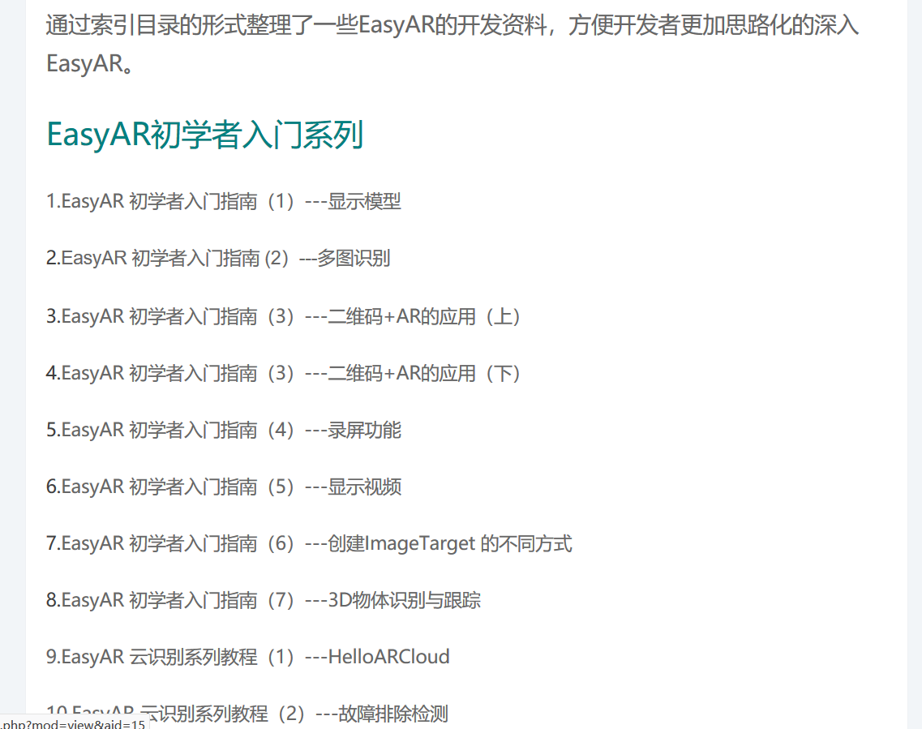

**However, regarding user experience, EasyAR has exposed its disadvantages. Is the most deadly model jitter problem. Regardless of the design, how complex the hierarchy of the recognition map is, the jitter problem is still serious. Because it is not a single case, the official made an official reply and proposed two solutions.**

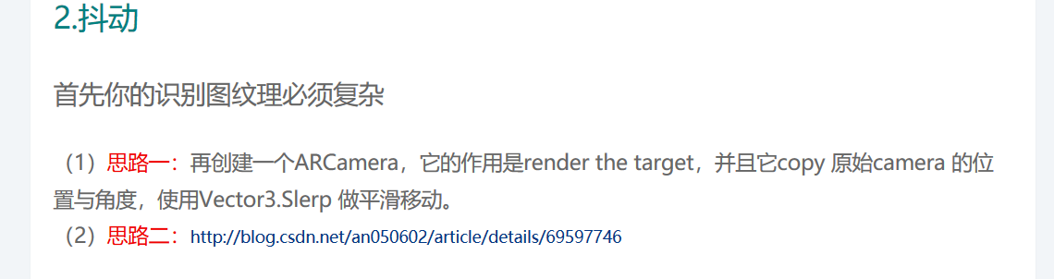

**One is to duplicate the camera so that the position theory of the two cameras is the same. If one of the cameras has a position drift, the other camera tracks the drifting camera and moves slowly to make the jitter unobtrusive and fail to solve the jitter problem. The second method,**

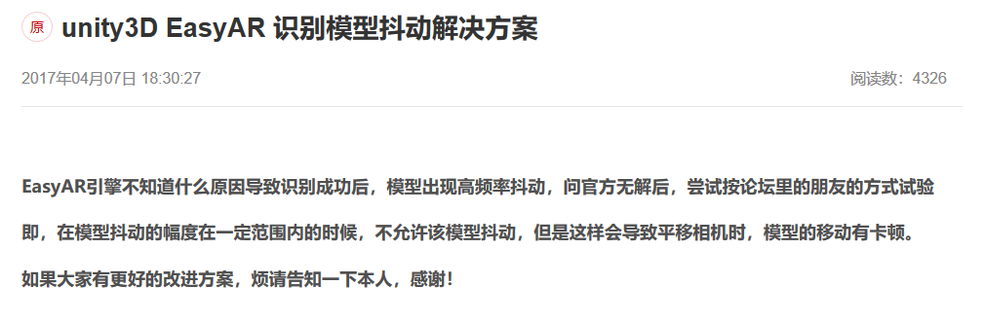

**The side effect is mobile stutter, so it is still a huge and heavy blow to the user experience. What about vuforia?**

**In the author's development, vuforia's jitter problem has not yet occurred, but because of vuforia's development documentation problems, although the industrial-grade foundation is laid, some "wheels" still need to be built. But because it is based on the Unity platform, there is less depth in vuforia.**

**In summary, the author chose the development method of unity + Vuforia.**

## 3.2 Particle System

## **Because the main presentation is a meteorological model, similar to fog, thunderstorm, snow, etc. The particle system must be selected.**

## **A particle system represents a technique for simulating some specific blurring phenomena in 3D computer graphics, which are realistic game physics that is difficult to achieve with other traditional rendering techniques. Particle systems often simulate phenomena such as fire, explosions, smoke, water currents, sparks, fallen leaves, clouds, fog, snow, dust, meteor trails, or abstract visual effects such as glowing trails.**

## **Usually the position and movement of the particle system in three-dimensional space are controlled by the emitter. The emitter is mainly represented by a set of particle behavior parameters and its position in three-dimensional space. Particle behavior parameters can include particle generation speed (that is, the number of particles generated per unit time), the particle's initial velocity vector (such as when and in what direction), particle lifetime (how long after the particle annihilates), particle color, and particle life cycle Changes, and other parameters. It is normal to use approximate values ​​rather than absolute values ​​for all or most of the fuzzy parameters. Some parameters define the central value and allowable changes.**

## **A typical particle system update cycle can be divided into two different phases: the parameter update / simulation phase and the rendering phase. Each loop executes each frame of animation.**

## **Simulation phase:**

## **In the simulation phase, the number of new particles is calculated according to the generation speed and the update interval. Each particle is generated in a specific three-dimensional space according to the position of the emitter and a given generation area, and the speed of each particle is initialized according to the parameters of the emitter. , Color, life cycle, and more. Then check if each particle has exceeded its life cycle. Once it is exceeded, remove these particles from the simulation process. Otherwise, change the position and characteristics of the particles according to the physical simulation. These physical simulations may be like adding speed to the current position or adjusting the speed offset. Friction is so simple, it may be as complicated as taking into account external forces to calculate the correct physical ejection trajectory. In addition, it is often necessary to check for collisions with special three-dimensional objects to make particles bounce off obstacles. Because collisions between particles are computationally expensive and not necessary for most simulations, collisions between particles are rarely used.**

## **Each particle system has specific rules for each of them, and usually these rules involve the interpolation process of the particle life cycle. For example, many systems interpolate the alpha value of an ion, or transparency, during the life of the particle until the particle annihilates.**

## **Rendering phase:**

## **After the update is complete, each example is usually rendered with a texture-mapped quad sprite, which means that the quad always faces the observer. However, this process is not necessary. In some occasions with low resolution or limited processing power, particles may only be rendered as one pixel, or even rendered as a metaball in offline rendering. The isosurface calculated from the particle metasphere can be A fairly good liquid surface was obtained. Alternatively, you can render particles with a 3D mesh.**

## **3DStudioMAX3 controls the interaction between a particle system and the scene through special spatial deformation, and also controls the reproducible characteristics of the particles themselves. These characteristics allow the particles to mutate, reproduce or die during collisions. Simply put, a particle system is a collection of particles that creates various animation effects while specifying the emission source while emitting a stream of particles. In 3DStudioMAX, a particle system is an object, and emitted particles are child objects. Animate the particle system as a whole, and adjust the properties of the particle system at any time to control the behavior of each particle. In 3DStudioMAX 1.0 version, the particle system has only two types: Spray (Spray) and Snow (Snow). Although they are the simplest particle systems, they work well, and they are still applicable when making flowing water, fountains, and dust. And the idea of ​​creating advanced particle systems is also based on the principles of Spray and Snow, but it only strengthens the function of animation designers to control particle behavior.**

## **3.3 Proposition of software prototype**

**In addition to the problems that should be solved, some auxiliary functions are also needed, such as the login function. Therefore, the software design scheme proposed by the author should be as follows.**

**First of all, the login interface, the software has a login registration function (because the QQ login interface is slow in application approval. Therefore, in the finished software, the QQ login is temporarily unavailable), and it can log in and register users, which is not only convenient for the last user management, but also A database interface is reserved for future user interaction development.**

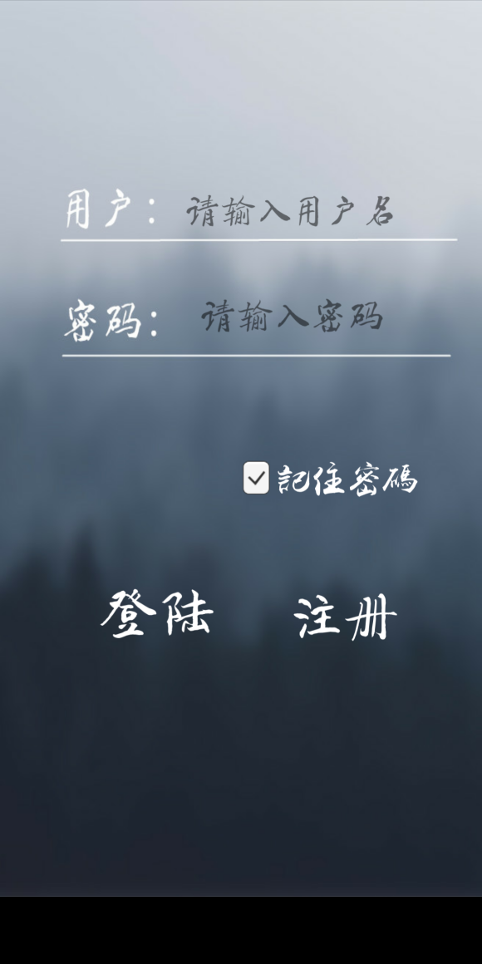 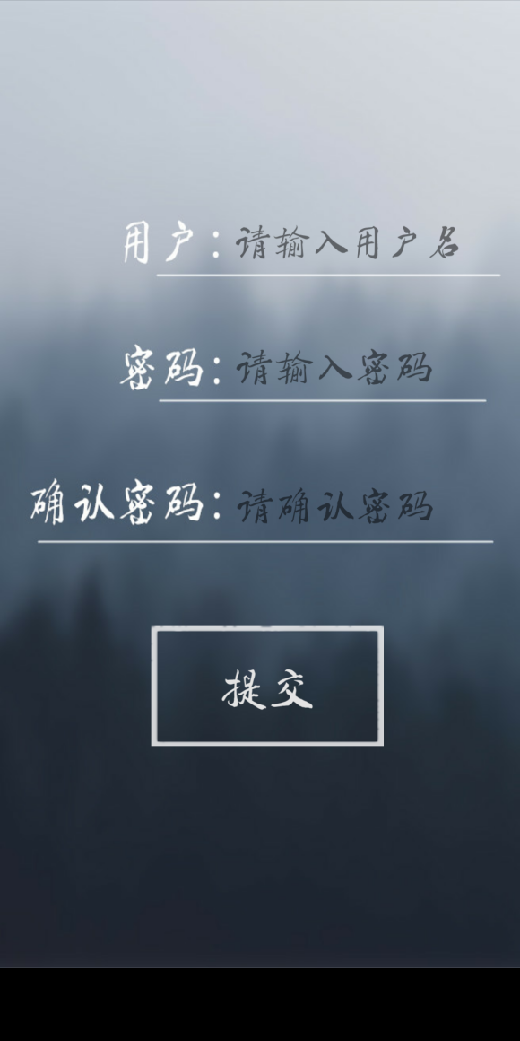

**Secondly, the interface needs to be loaded asynchronously. When the main interface is dynamically loaded in the background, a loading waiting interface appears first, so that after the main interface is loaded, and after jumping, it can effectively avoid the phenomenon of stutter.**



**After coming to the main interface, turn on the camera. At this point, the target picture is scanned. A corresponding 3D model will appear. At this time, in the 3D model, there is a "Next Weather" button. If the user clicks, it will switch to the particle model display of the next climate disaster. The user seems to be in it and can Get up close and see the details of the climate.**

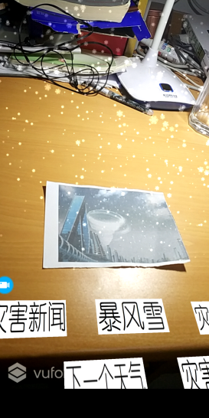 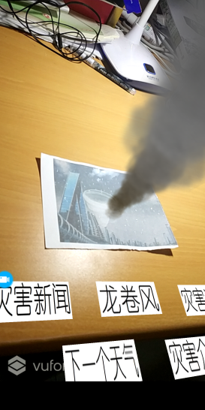 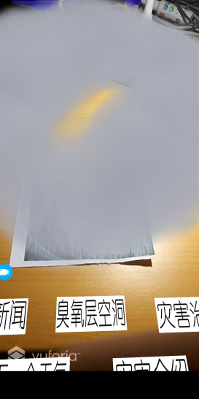 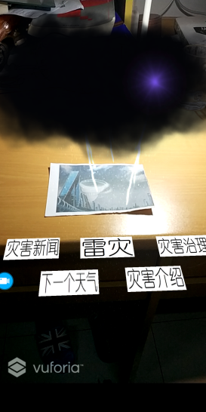

**Then, with the back button (here the test phone is MIX2, there is no back button in full screen mode, and you can return by sliding your finger at the edge of the screen to return), at the same time, 4 buttons will appear at the bottom of the video. There are disaster news, disaster management, next weather, and disaster introduction. Among them, the "next weather" button is at the top and its function is introduced. Now we will focus on the three remaining buttons. "Disaster News" is a link that clicks to jump to the news of the disaster weather viewed by users. Can let users know the latest news of the severe weather. Followed by "disaster management", this button will jump to some governance methods for the current climate. This button is also the focus of this software. It plays the role of science and can add more content later. If the software is promoted, you can In cooperation with the Ministry of Education, etc., the latest prevention methods and the latest climate crisis will be updated to the software for users to view at any time. As for "disaster introduction", it is one of the most basic functions of this software. The jump page here is the introduction to Baidu Encyclopedia's disaster. The Baidu Encyclopedia's introduction is more comprehensive, so it is filtered out here, and more disaster climates will be added later. Later, if you can get more details about the disaster or have the latest research results and reports, you can also join this software. Strive to give users the most convenient and fun practical experience.** 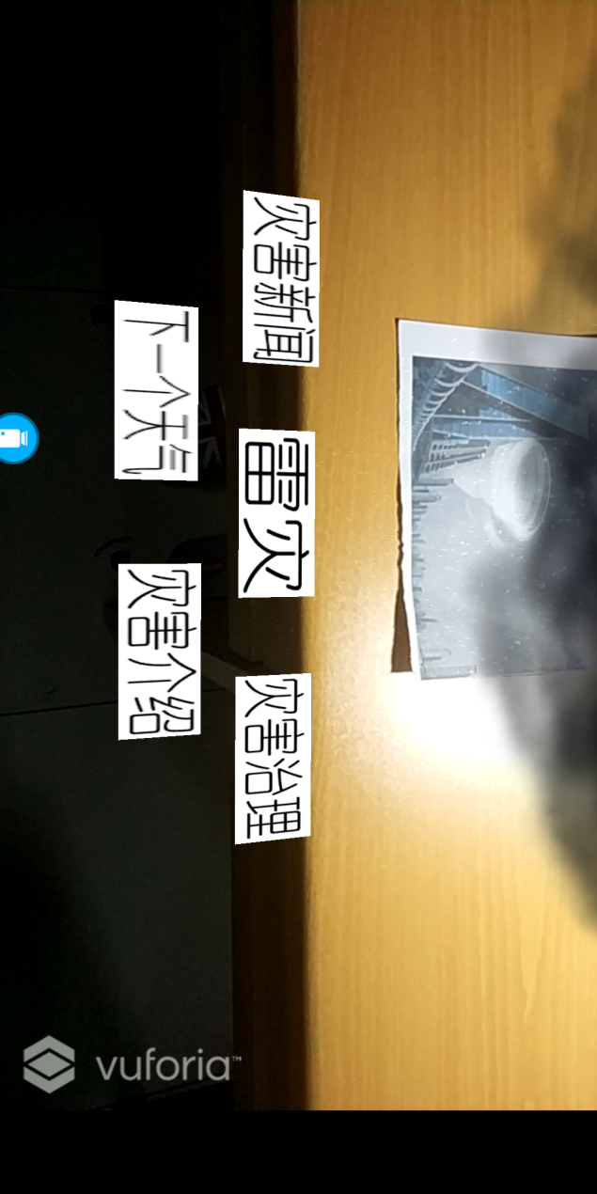

**For details, see 4.3 Software Modules and Interfaces.**

## **3.4 Optimization of this software**

**The first is an asynchronously loaded application. We can often see in the software that we are using. If we just open the software, a loading interface will appear. It will not jump until the main interface is loaded in the background. At the beginning, the author did not use the asynchronous loading method. After the user registered or logged in, the software would jump directly to the main scene. At this time, the items in the main scene were not completely loaded, so there would be a severe freeze. phenomenon. Although the lag will disappear after waiting for more than ten seconds, but the user experience is not good, so I added asynchronously loaded applications. First, after registering or logging in, I jumped to the loading interface and arrived at the loading interface to start asynchronously loading the main scene. . And "inquire" about the loading progress at any time. After the loading is completed, jump from the loading interface to the main scene. Of course, because the scene is jumped, there will still be a pause of one or two seconds when the target picture is scanned (this can be reflected in the specific demonstration video), and the pause at this time is completely acceptable.**

**Then the optimization of the UI, because of the characteristics of AR's mixed reality, so if a two-dimensional UI is used in the main interface, one will not have much impact on performance, but there are multiple two-dimensional UIs with different depth information. , It will cause unnecessary calculation. Therefore, the author chooses to change the UI to a three-dimensional UI with a space, and then adjusts the height on the Y axis to compress it to approximate a plane, which has the effect of what now looks like a two-dimensional UI. At this point, another option appeared in front of the author: Vuforia's unique virtual button selection. By covering the part of the recognition map, it was determined when the button was pressed. However, after the author ’s experiments, because I ’m holding the phone in my hand, if I press the recognition picture again, it ’s inconvenient to hold the phone. Not to mention that sometimes I have to close the book by myself, and I need to open it by hand. Interact with the screen instead.**

## 3.5 Advantages of this software

## **In recent years, with the continuous development of China's economic and social construction, the traditional meteorological science and popularization work methods have shown some deficiencies and it is difficult to meet the needs of the new period. In the new era of China's economic construction, socialization is an important development strategy for meteorological science. Under the current situation, analyzing the socialization of meteorological science has an important practical significance. The traditional science popularization method is not only ignored, but also has a lot of economic costs. Such as popular science books, popular science brochures and so on. Therefore, the combination of fun and science can make a better publicity effect.**

## **Sociology refers to the discipline that takes human social behavior as the research object. The main research focus is the social behavior of modern human beings. It is a discipline that studies the development of modern society and the behavior of social organizations and groups. However, popular science of meteorology itself is one of the important contents and essence of meteorological sociology. Its main purpose is to improve the public's awareness and prevention of meteorological disasters, and to play an important role of government departments in meteorological disaster prevention and reduction. In 2011, China Meteorological Administration issued the "Opinions on Strengthening Meteorological Science Popularization Work", and put forward the business, socialization, normalization, and branding development concepts for meteorological science popularization work in the new era. Therefore, in the current situation, strengthening the socialization of meteorological science popularization and giving full play to the socialization of meteorological science popularization is the primary problem that the current meteorological work needs to face.**

## **And this problem, through our software, can solve some meteorological science insufficiency and insufficient problems. We integrated the science popularization content of meteorology into a software by searching on the Internet. The knowledge acquisition was large and the model was presented accordingly, so that the user and the meteorology contact more closely. The model can evoke more people's Interest makes it a knowledge helper in the fast-paced life of modern young people. The development of meteorological science has been promoted, and the way people acquire meteorological knowledge has become more diverse and convenient.**

## 3.6 Algorithms of this software

**This software cooperates with six modules to realize software functions, including login and registration module, 3D model identification module, model switching module, disaster news jump module, disaster management jump module and disaster introduction jump module. The ideas and algorithms of each module are listed in detail in 4.3.**

# Ⅳ、Software structure, function, module, interface, etc.

## 4.1 Software structure

**The software structure is shown in the figure below. Boxes indicate the main interface and the information in the interface.**

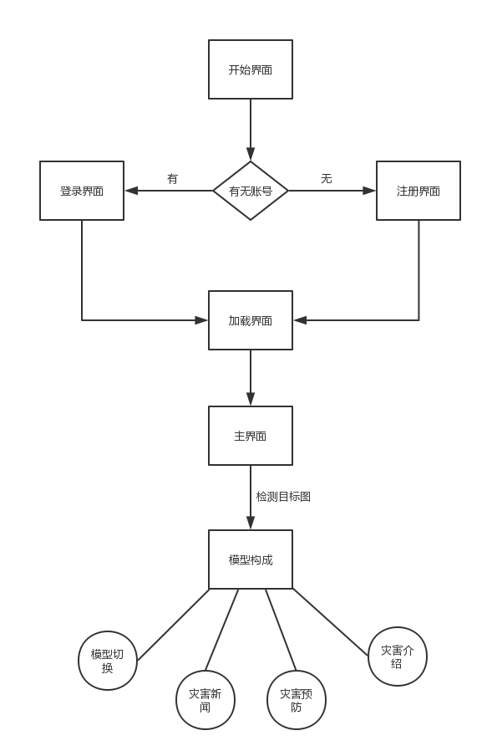

## 4.2 Software functions

**Same as the prototype of 3.3 software.**

**First of all, the login interface, the software has a login registration function (because the QQ login interface is slow in application approval. Therefore, in the finished software, the QQ login is temporarily unavailable), and it can log in and register users. A database interface is reserved for future user interaction development.**

**Secondly, it is necessary to load the interface asynchronously. When the main interface is dynamically loaded in the background, the loading waiting interface appears first, so that after the main interface is loaded, and after the jump, the stuttering phenomenon can be effectively avoided.**

**After coming to the main interface, turn on the camera. At this point, the target picture is scanned. The opposite 3D particle model will appear. Users can view the details and the whole of the model by approaching the target picture or away, or observe the climate models at different angles by looking at different angles.**

**Then, click the "Next Weather" button to switch to the next climate model. There are a total of four groups of models (more climates can be added in the future, and only these four climates are shown for the time being). The jump buttons corresponding to each model Are all different.**

**Click the disaster news button below, and the software will jump to the news report website of the corresponding disaster. Provide users with relevant information. Clicking the disaster management button or disaster introduction button will also jump to the corresponding information page. The content on the page gives users a comprehensive view of the climate.**

## 4.3 Software modules and interfaces

### 4.3.1 Login and Registration Module

**Without using an interface, the UGUI built with the Unity engine is used to convert the information entered by the user into a json format and send it to the server for storage and other operations (because the development time is short and is not the main function, so The first implementation is the local storage and registration function, which will be presented later on the server side)**

### 4.3.2 3D particle model rendering module

**Using the vuforia interface, first move the ImageTarget in vuforia to the current scene, and delete the Camera in the original scene of unity. Use the model to be displayed as a child of ImageTarget, and you can see the effect when running (the video section is listed separately)**

### 4.3.3 Model switching module

**Instead of using interfaces, the function is to switch models and related components. The idea is to set up a switch script and a function to trigger the event. Since the flat 2DUI makes the program run slower, I chose to create a cube named "Next Weather" as the trigger object, and adjust its thickness, that is, the height of the Y axis, to a smaller value to make it look similar to A flat 2DUI that triggers a function call OnMouseDown. (It writes a function on the PC side, but when it runs to the mobile side, Unity will automatically convert it to a finger touch, instead of really requiring a mouse click. The specific code is implemented in the source code (Including comments), after clicking, you can jump to the displayed model according to the corresponding code, and eliminate the previous model, and the corresponding components of the corresponding model will also change.**

### 4.3.4 Disaster News Jump Module

**When the screen ray detects that the user clicks on the disaster news, it switches the interface to the news page of the relevant model. Still use OnMouseDown as the basis, use the characteristics of the web page, use Unity's Application.OpenURL function, jump to the corresponding web page.**

### 4.3.5 Disaster Prevention Jump Module

**Similar to the disaster news jump module, when the screen ray detects that the user clicks to disaster prevention, the interface is switched to the prevention information webpage of the relevant model. It is still based on OnMouseDown and uses Unity's Application.OpenURL function to jump to the corresponding web page.**

### 4.3.6 Disaster introduction jump module

**Similar to the disaster news jump module, when the screen ray detects that the user clicks on the disaster introduction, the interface is switched to the Baidu Encyclopedia introduction page of the relevant model (this page called in the display. In the future, more authoritative introduction information can be added directly. ). It is still based on OnMouseDown and uses Unity's Application.OpenURL function to jump to the corresponding web page.**